Q1) Graphs are in the document.

Q2) While orderings 1,2,3 and 5 have small differences, the overall Flops curve remains similar.

In orderings 4 and 6 however, the curve is dramatically different, with ordering 6 having the similar drop in performance of the other orderings, but order 4 is increasing in performance over time.

Q3) Yes. Except for ordering 4, the larger the value of n, the lower the Flops.

Peak flops for my CPU:

CPU: Intel i7-6700HQ

Peak Flops: 47.09 GFlops

Process for finding the information:

Went to Intel's support page. Found my processor family, then clicked on 'Product Information and Documentation'.

Tried to find my processor and could not.

So, gave that up and just googled 'i7 6700HQ Flops'

Found a result on sisoftware.net that told me it's 47.09 GFlops for General Matrix Multiplication.

Graphs for normal Matrix Multiplication:

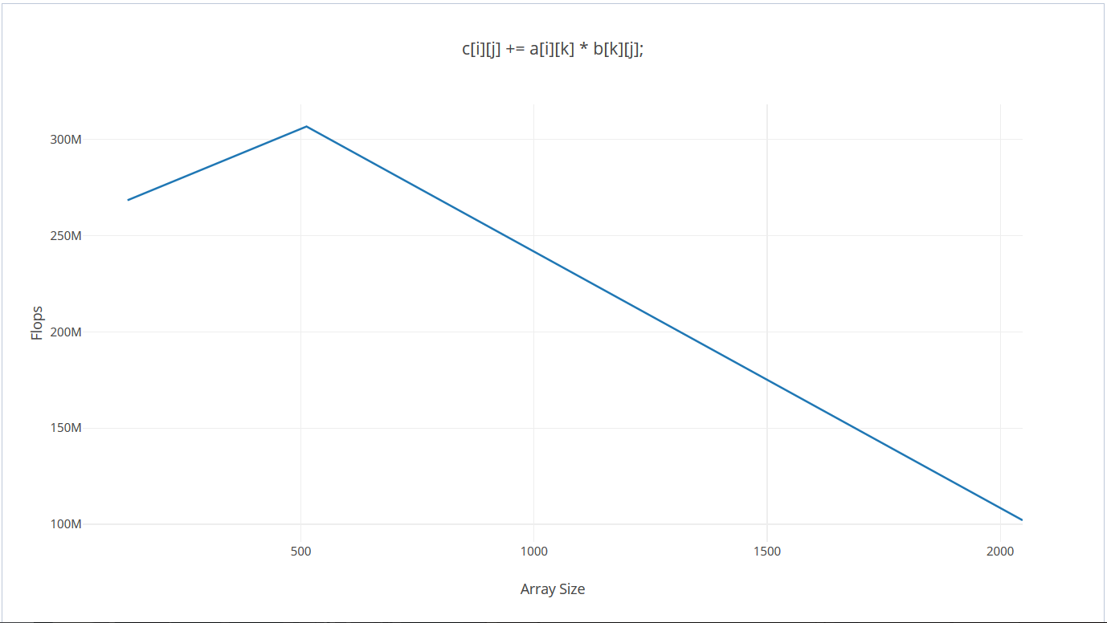

**Ordering 1**

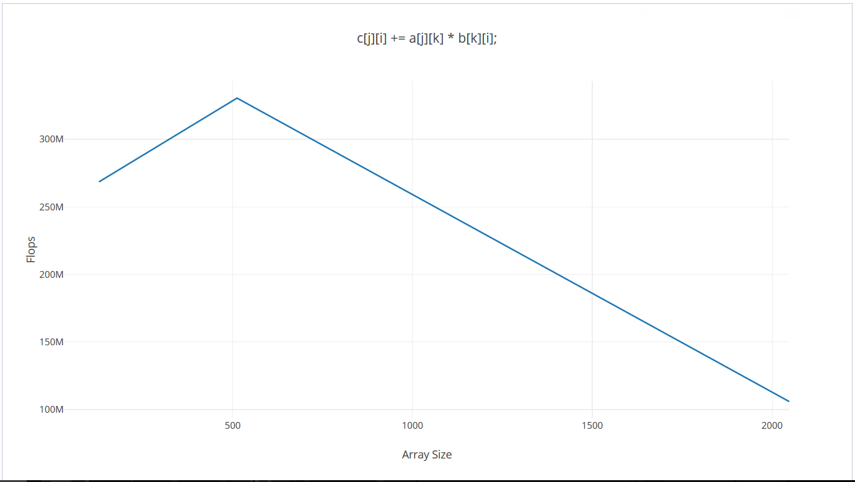

**Ordering 2**

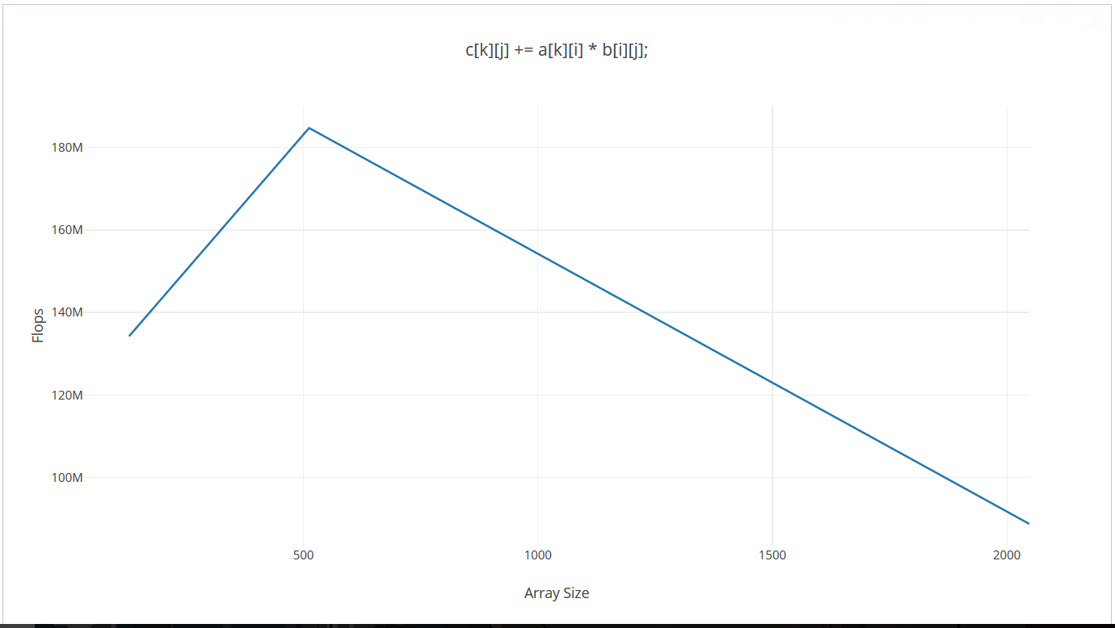

**Ordering 3**

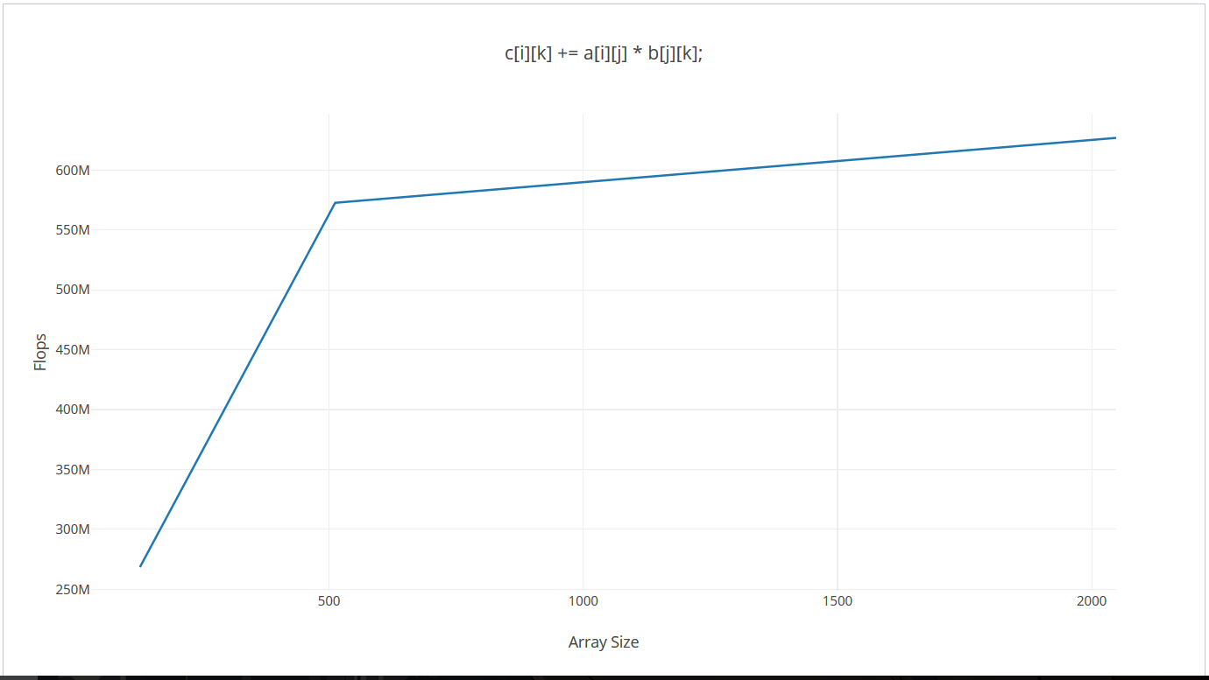

**Ordering 4**

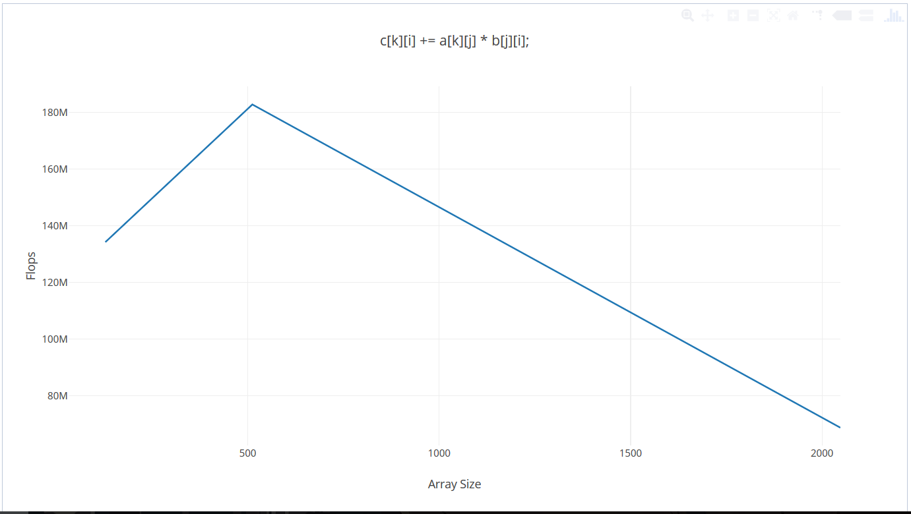

**Ordering 5**

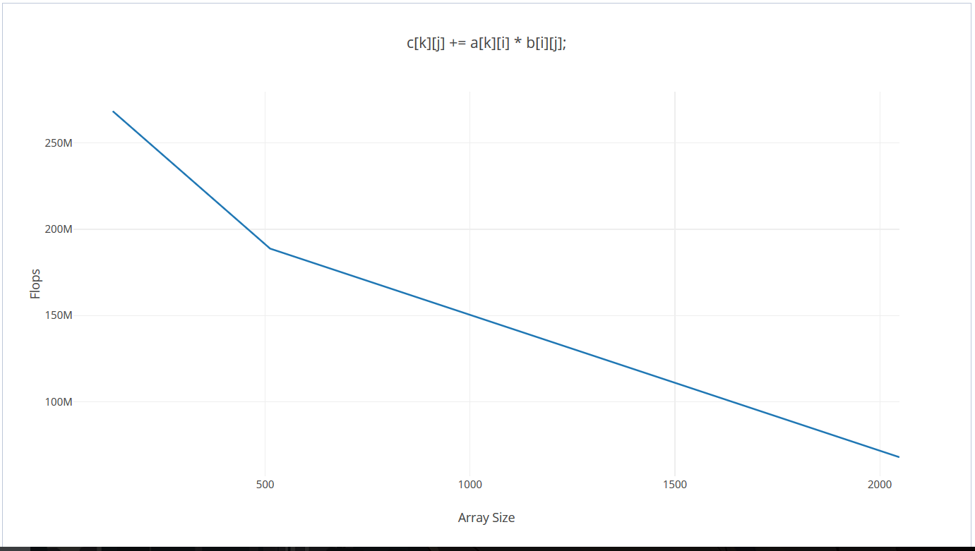

**Ordering 6**

Graph for tiled matrix multiplication:

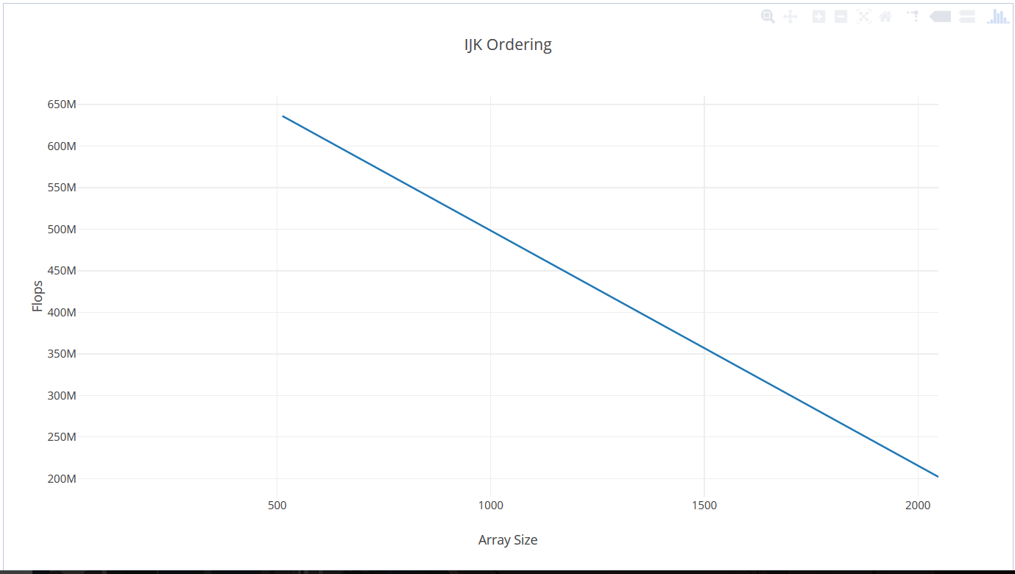

**Ordering 1**

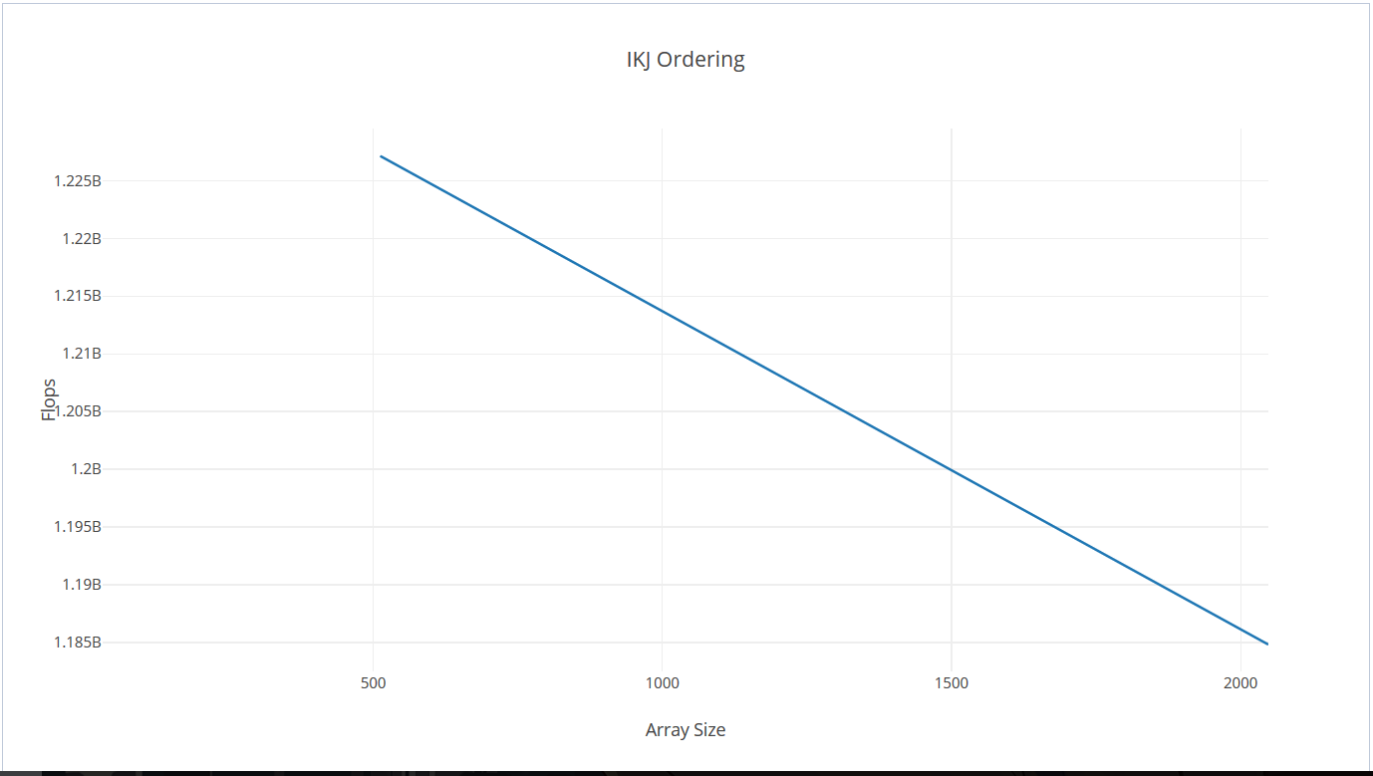

**Ordering 2**